

**Mental Health First Aid Champion**

[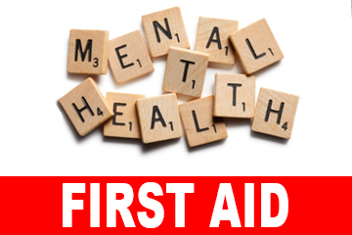](https://www.google.com/url?sa=i&rct=j&q=&esrc=s&source=images&cd=&ved=2ahUKEwi4iP_TwObiAhUMyxoKHXsPDxQQjRx6BAgBEAU&url=https://www.nnetwork.org.uk/news/free-mental-health-first-aid-training/&psig=AOvVaw0VDKHsw2gtFZ2i6YKMb1IO&ust=1560516895890376)

**The one-day Youth MHFA Champion course will provide:**

* An understanding of common mental health issues and how they can affect young people
* Knowledge and confidence in dealing with mental health issues on a first aid basis
* A level of awareness to effectively spot signs of mental ill health in young people and guide them to a place of support
* Knowledge and confidence to advocate for mental health awareness
* Skills to support positive wellbeing
* An understanding of how to effectively support the school’s Mental Health First Aid Lead

For schools who already have a trained Mental Health First Aid Lead, the one-day Champion course is intended to provide training for additional members of their staff. This will help schools to build a team with knowledge in the issues of youth mental health to provide effective support for the school’s Mental Health First Aid Lead

£125 + Vat

£78 for REAL Trust members

The Training Suite

Hopwood Primary

Following completion of the day participants will get a MHFA manual to keep and refer to whenever needed and a Youth MHFA Champion certificate.

**Autumn Term:**

8th October 2019 9.30am – 4.30pm

**Spring Term:**

21st January 2020 9.30am – 4.30pm