

**TEAM TEACH Positive Handling Course**

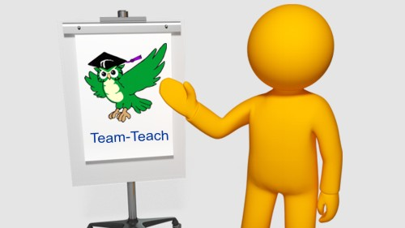

Donna is an Advanced Senior tutor in Team Teach Positive Handling.

She has led courses since 2008 and many hundreds of schools and care staff have benefitted from her wealth of experience and honest approach.

Team Teach is an accredited comprehensive course for staff working with challenging children in any role. It is preferred by many Local Authorities as it has a big emphasis on de-escalation and reducing Physical Intervention. The physical techniques taught are a minimal part of the course and range with consideration for age and size and only age appropriate techniques are taught.

**The course covers:**

• Understanding why children are aggressive

• What the current Law and the Guidance says and about staff staying safe

• De-escalation techniques and personal awareness

• Physical techniques in escorts, guides and restraints.

• Recording, reporting and policies.

**Autumn Term:**

3rd & 9th October 2019

3.45pm – 6pm

**Spring Term:**

28th January & 4th February 2020 3.45pm – 6pm

**“**The course gave a good balance of theory and physical knowledge increasing my confidence**”**

The Training Suite  
Hopwood Primary

£100 + Vat

£59 REAL Trust Members