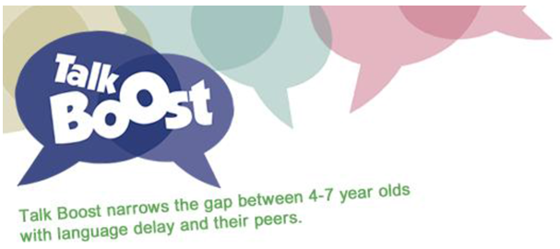
I CAN Talk Boost
What is Talk Boost? Talk Boost KS1 is a targeted and evidence-based intervention, which supports language delayed children aged 4-7 years in Reception and Key Stage One (KS1) to make progress with their language and communication skills. The structured programme boosts children’s progress in language and communication by an average of 18 months after a ten week intervention.
Can be delivered using Pupil Premium/Early Years Pupil Premium
Course Objective: The training will give participants the skills and knowledge to understand the rationale behind Talk Boost, identify appropriate children, measure their progress and deliver the intervention successfully.
Tutors: Sue Stopforth (Specialist Teacher) and Grace Farrell (Speech & Language Therapist)
Licensed I CAN Tutors from the RANS Talk to Learn Team (formerly SLI Team)
Date: Friday 20th October 2017
Venue: Hopwood Hall College, Rochdale Campus
Audience: Teacher/Senco and Teaching Assistant pairs
This is planned so that a TA can deliver the intervention while the Teacher/Senco is expected to make links from the intervention to class teaching each week and take responsibility for each child’s learning.
Cost: Training is free for REAL Trust members.
If you decide to offer Talk Boost you will need to purchase the toolkit from I CAN at £350. All resources are provided in the toolkit. The activities are clearly planned, organised, concise, convenient, and focused. They cover: Attention and Listening, Vocabulary, Building Sentences, Telling Stories and Conversation Skills
Additional resources, including all of the activities made into games and the objects needed to complete Talk Boost KS1, have been made into a Toolkit costing £175. This is an optional resource. Both a Starter Kit and Toolkit can be bought together at the same time as a bundle for a discounted price of £480. Further details: http://www.ican.org.uk/talkboost
Booking Details: Please see REAL Trust website. info@realtrust.org.uk 01706 926708

