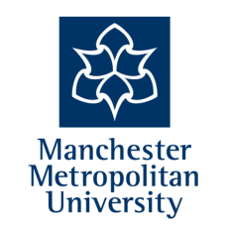
Free Physics CPD
Teacher Subject Specialism Training (TSST) Course
Summer Term 2018/19

Do you have colleagues who are:
- Non-specialist teachers who could potentially teach Physics in addition to, or as their main subject?
- Non-specialist teachers who are currently teaching Physics (either full-time or in addition to their specialist subject)?
- Teachers who are looking to return to the profession to teach Physics?
If so, we currently have places available on the Physics TSST. This free of charge course has been designed to improve the subject knowledge of non-specialist teachers (trained in Biology, Chemistry or another non-Science subject) or returning teachers. There will be a focus on teaching and learning through experimentation facilitated by Manchester Metropolitan University at Middleton Technology School on the dates below.
The course will start on Monday 20th May through a series of twilights, online resources and 1 full day after the Science GCSE exams have taken place.
Date | Session | Time
Monday 20th May 2019 | Introduction & Gas laws | 4-6pm
Online materials
Monday 3rd June 2019 | Forces, movement | 4-6pm
Online materials
Thursday 20th June 2019 | Electricity and light | 9-3pm
Online materials
Monday 1st July 2019 | Energy and space | 4-6pm
Online materials
Monday 15th July 2019 | Electromagnetism, Atoms, summary, reading | 4-6pm

To book a place (closing date Monday 13th May) or for further information, please contact:

Kate Davies
Director of Teaching School
Middleton Technology School
Contact Email: mtskdavies@middtech.com
Tel 0161 643 5116

More information about TSSTs and a full list of eligibility criteria can be found at:
https://www.gov.uk/guidance/teacher-subject-specialism-training-courses

